SMART TRAFFIC MANAGEMENT USING SWARM INTELLIGENCE
AI-Driven Citywide Traffic Control using PySpark and RDDs

1. Introduction
Smart Traffic Management is an AI-driven system that monitors traffic from cameras and road sensors, processes the incoming data using Apache Spark and Resilient Distributed Datasets (RDDs), and dynamically adjusts traffic signals. Each intersection is treated as an intelligent agent. These agents cooperate like a swarm: they share local traffic information and coordinate decisions so that improving one junction does not create congestion at the next junction.

2. Objectives
- Reduce congestion, queue length, waiting time and overall travel time.
- Process thousands of vehicle events simultaneously using distributed PySpark analytics.
- Adapt traffic-signal timings in near real time according to current traffic conditions.
- Coordinate neighboring intersections through swarm intelligence.
- Detect incidents, unusual traffic patterns and possible bottlenecks early.

3. System Architecture
The system follows a distributed pipeline: traffic cameras and sensors generate data → an ingestion layer receives events → PySpark converts and distributes the data into RDD partitions → parallel transformations and actions compute traffic metrics → each intersection agent receives its local state plus neighboring-agent information → the swarm coordination logic selects signal actions → traffic lights are updated → performance data is stored for analytics.
- Data sources: CCTV cameras, loop detectors, radar sensors, GPS/vehicle data and signal-controller status.
- Processing layer: PySpark with RDDs for distributed storage and parallel computation.
- AI layer: congestion scoring, anomaly/incident detection and signal-decision logic.
- Swarm layer: neighboring intersection agents exchange queue, flow and predicted-arrival information.
- Control layer: adaptive green/red durations, phase selection and coordination across corridors.
- Dashboard layer: live map, signal status, alerts and performance reports.

4. Role of PySpark and RDDs
RDDs are distributed collections that can be processed in parallel across Spark workers. For traffic management, each incoming event can contain a timestamp, vehicle count, speed, lane, camera ID and intersection ID. PySpark can transform these events into useful metrics without sending all computation to one central machine.
- map(): converts raw sensor/camera events into structured traffic records.
- filter(): removes invalid, duplicate or noisy readings.
- mapValues()/groupByKey(): organizes traffic information by intersection or road segment.
- reduceByKey(): aggregates vehicle counts, speeds and queue estimates efficiently.
- union(): combines data from multiple sensor/camera streams.
- cache(): keeps frequently used RDD data in memory when repeated analysis is required.
- Parallel partitions: allow many intersections and road segments to be analyzed at the same time.

5. Swarm-Based Coordination Among Intersection Agents
Every traffic intersection acts as an autonomous agent. An agent observes its own traffic state and communicates with nearby agents. Instead of using one controller for the entire city, many small agents make local decisions while following shared objectives. This resembles swarm intelligence used by ants, bees or birds: simple local interactions produce useful global behavior.
- Local observation: queue length, arrival rate, speed, occupancy and current signal phase.
- Neighbor exchange: send predicted vehicle arrivals, queue pressure and planned signal changes to nearby agents.
- Shared objective: minimize total delay and prevent queues from propagating to neighboring intersections.
- Cooperative decision: an agent can extend or shorten a green phase when neighboring traffic conditions justify it.
- Feedback: after a signal change, the next sensor measurements are used to evaluate the result and adjust again.

6. Real-Time Signal Adaptation
The controller repeatedly calculates a traffic-pressure score for each approach. A simple conceptual score can be based on queue length, waiting time, arrival rate and downstream congestion. If one approach has a high score, the agent can safely extend its green period. If downstream congestion is high, the agent can avoid releasing more traffic into the blocked segment. Signal decisions are therefore adaptive rather than fixed-time.

Example decision flow:
- Read latest sensor and camera events.
- Create/update the traffic RDD.
- Calculate intersection queues, speeds and arrival rates.
- Receive neighboring-agent state.
- Estimate congestion pressure and downstream capacity.
- Select the next phase and green duration.
- Send the signal command to the controller.
- Measure the outcome and repeat.

7. Scalability for Thousands of Vehicles
Because Spark distributes RDD partitions across multiple workers, traffic data from many intersections can be processed simultaneously. The system does not need to analyze every vehicle on a single server. As the city grows, additional Spark workers can be added to increase processing capacity. This makes the architecture suitable for large-scale citywide analytics.
- Horizontal scaling: add Spark worker nodes as data volume increases.
- Partitioning: distribute records by intersection, road segment or time window.
- Fault tolerance: RDD lineage helps Spark recompute lost partitions after worker failures.
- Parallel aggregation: traffic metrics for thousands of vehicles can be calculated concurrently.
- Near-real-time operation: short processing windows allow signal agents to react quickly to changing traffic.

8. End-to-End Working
Cameras/Sensors → Data Ingestion → PySpark RDDs → Cleaning & Transformation → Traffic Metrics → Swarm Coordination → Adaptive Signal Control → Feedback
In practice, the cycle runs continuously. A sudden increase in traffic at one junction changes its local state. The neighboring agents receive this information, estimate the effect on approaching traffic, and coordinate their signal timings. This prevents a local improvement from simply moving the congestion to another intersection.

9. Main System Screens

Screen 1 — City Dashboard
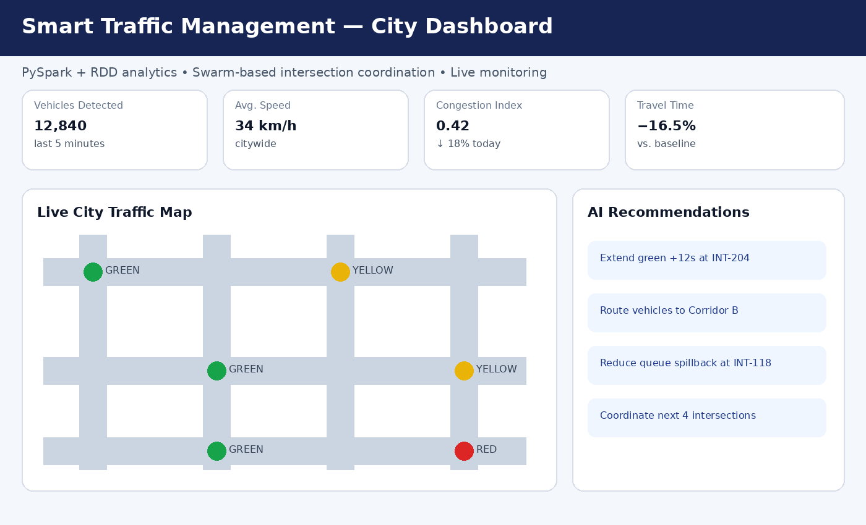
Shows citywide vehicle count, average speed, congestion index, travel-time improvement, live intersection states and AI recommendations.

Screen 2 — Intersection Agent Control
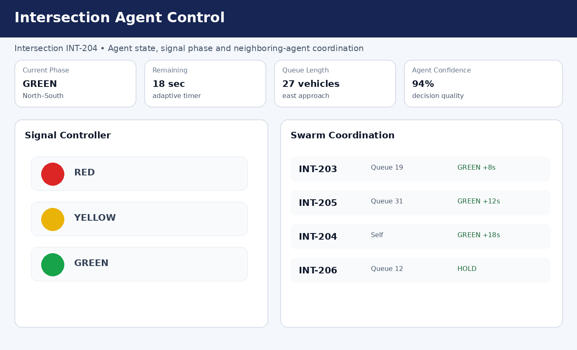
Shows an individual intersection's signal phase, remaining time, queue length, confidence and neighboring-agent coordination.

Screen 3 — Real-Time PySpark Analytics
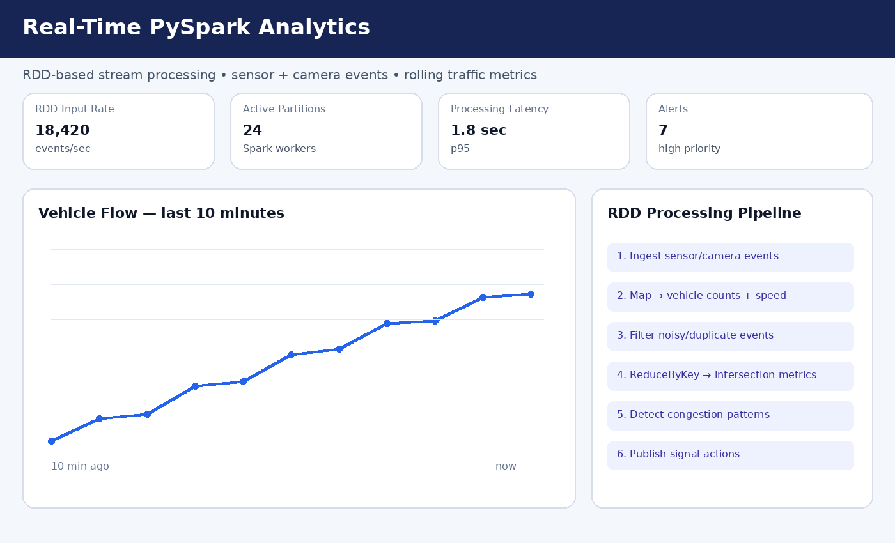
Shows RDD input rate, Spark partitions, processing latency, alerts and the distributed analytics pipeline.

Screen 4 — Live Sensor & Camera Monitor
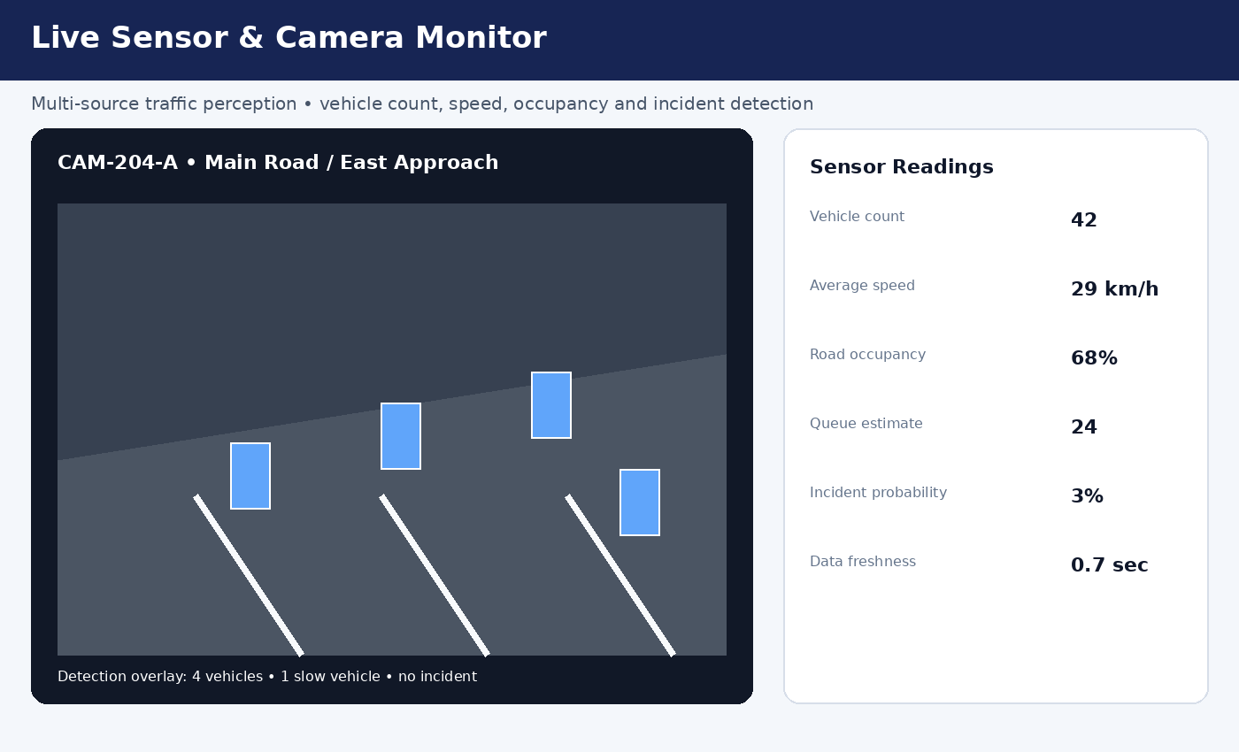
Shows a camera/sensor view with vehicle detections and live readings such as speed, occupancy and queue estimate.

Screen 5 — Performance & Optimization Report
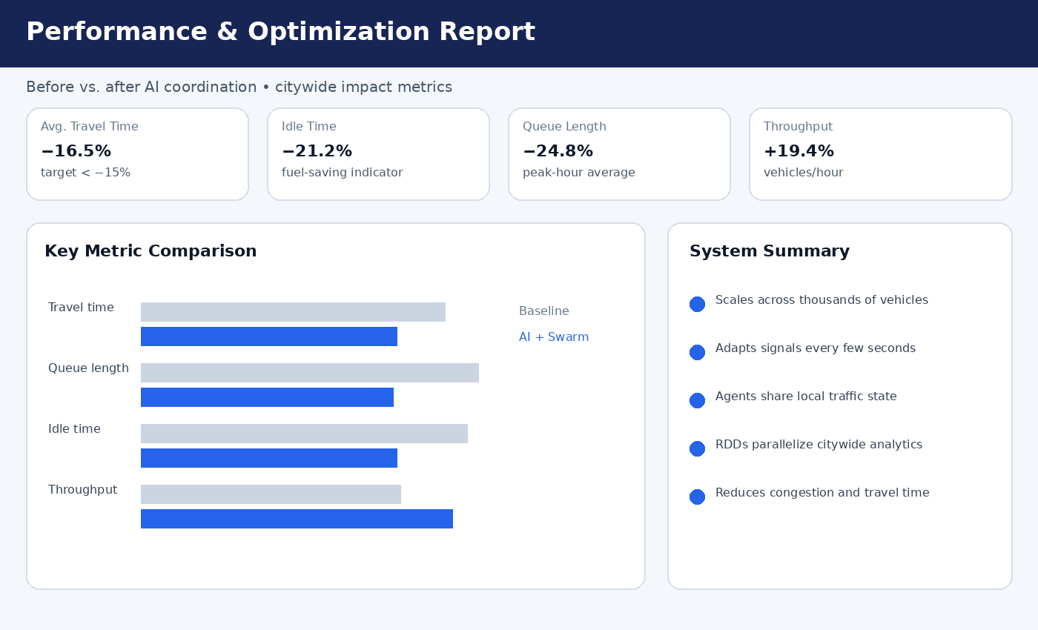
Summarizes the impact of AI and swarm coordination using travel time, queue length, idle time and throughput metrics.

10. Expected Benefits
- Lower average travel time and waiting time.
- Shorter queues and reduced stop-and-go traffic.
- Better coordination between adjacent intersections.
- Faster identification of incidents and abnormal traffic conditions.
- Scalable processing for citywide traffic streams.
- Data-driven reports for traffic planners and future infrastructure decisions.

11. Conclusion
The proposed Smart Traffic Management System combines PySpark, RDD-based distributed analytics and swarm intelligence to create a responsive citywide traffic-control network. Intelligent intersection agents continuously observe traffic, share information with neighbors and adapt signal timings. By processing large volumes of traffic data in parallel, the system can reduce congestion and travel time while remaining scalable as the number of vehicles and intersections grows.

